UWGB PRIDE ERG  -Employee resource group-  uwgb pride erg is open to all EMPLOYEES!  just be kind - this is an inclusive space.  allies & lgbtqia+ Welcome!  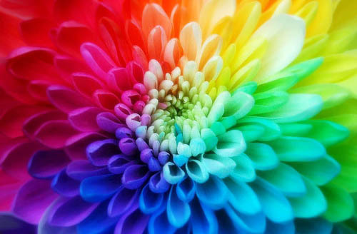  TUESDAY LUNCHES AT pride center-main campus  BRING YOUR OWN LUNCH AND SOCIALIZE!  12:00PM-1:00PM  JUNE 7, 14, 21. JULY 26. AUGUST 2, 9, 16.  SUMMER BOOK CLUB: june 27 – july 27, 2022  discussion july 27th (1:30PM-2:30PM)  LAST NIGHT AT THE TELEGRAPH CLUB  BY: MALINDA LO | summer 2022 events  june – pride month  21 – TIMBER RATTLERS  PRIDE NIGHT  6:40PM – APPLETON, WI  25 – OPEN DOOR PRIDE  10:00AM-5:00PM – STURGEON BAY, WI  JULY  17 – DIVA BRUNCH AT HAMBURGER MARY’S  11:30AM-12:30AM – MILWAUKEE, WI 17 – THE HISTORY OF MILWAUKEE DRAG  3:00PM-4:00PM – MILWAUKEE, WI  17 – WAR ON THE CATWALK  7:30PM - GREEN BAY, WI  AUGUST 11 – AXE THROWING 6:30PM - GREEN BAY, WI  *Posters with more information will be posted in the log. If you want to get added to the PRIDE ERG group – email Nicole. Please follow the UWGB Pride Center on face book!  QUESTIONS?  Pride ERG Chairs:  Nicole Kurth  Pride Center Coordinator  She/Her/Hers  (920)465-2167  kurthn@uwgb.edu  James Zarling  Conduct & Student Support Coordinator  He/Him/His  (920)465-2236  zarlingj@uwgb.edu  