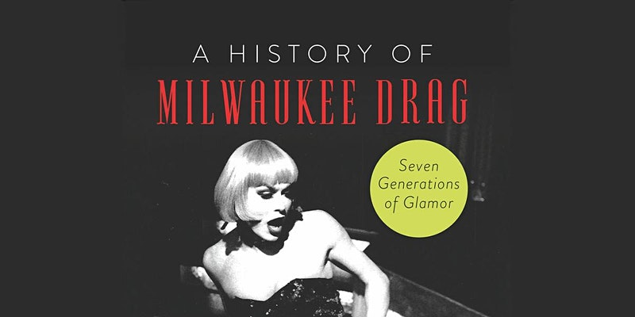  july 17, 2022  HISTORY PRESENTATION BY MILWAUKEE DRAG LEGEND: BJ DANIELS AND LONGTIME LGBT HISTORIAN: MICHAIL TAKACH  3:00pM-4:00PM  SAINTE KATE – THE ARTS HOTEL:  139 EAST KILBOURNE AVENUE – MILWAUKEE, WI 53202  FREE – LIMITED NUMBER OF TICKETS  *EMAIL NICOLE BY 6/30 TO RESERVE YOUR TICKET!  JULY 17, 2022  WAR ON THE CATWALK  COME SEE YOUR FAVORITE QUEENS FROM AROUND THE WORLD AS THEY PERFORM LIVE ON STAGE.  7:30PM  weidner center for the performing arts:  2420 nicolet drive – green bay, wi 54311  TICKETS ARE $40.50 + $5.50 PER TICKET FEE  *TICKET INFO HERE | SUMMER 2022  UWGB PRIDE ERG  -Employee resource group-  uwgb pride erg is open to all EMPLOYEES!  just be kind. this is an inclusive space.  allies & lgbtqia+ Welcome!  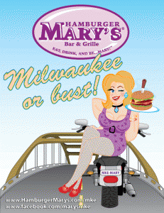  JULY 17, 2022  DIVA BRUNCH AT HAMBURGER MARY’S  JOIN THE PRIDE CENTER AT 11:30AM-12:30PM BRUNCH AT HAMBURGER MARY’S IN MILWAUKEE. PLEASE EMAIL NICOLE BY 6/30 IF YOU’RE GOING FOR RESERVATIONS.  HAMBURGER MARY’S  730-734 South 5th Street  Milwaukee, WI 53204  $6 SHOW FEE. $10 MINIMUM PURCHASE PER PERSON FOR ALL SHOWS.  QUESTIONS?  Pride ERG Chairs:  Nicole Kurth  Pride Center Coordinator  She/Her/Hers  (920)465-2167  kurthn@uwgb.edu  James Zarling  Conduct & Student Support Coordinator  He/Him/His  (920)465-2236  zarlingj@uwgb.edu

