SUMMER BOOK CLUB  read in june/july. discuss: july 27, 2022  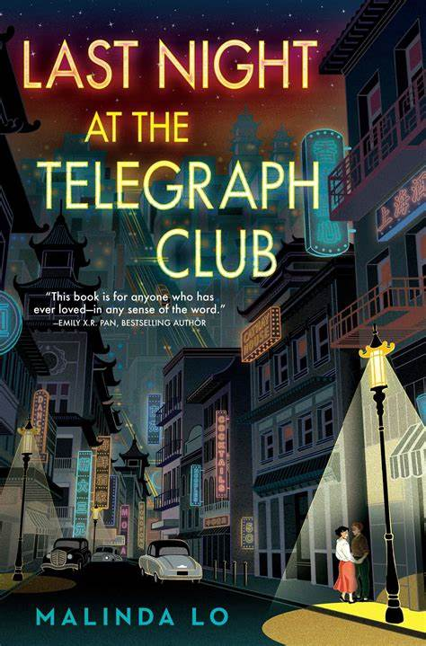  DISCUSSION:  JULY 27: (1:30PM-2:30PM)  via Teams or in-person – pride center main campus  PLEASE EMAIL : pridecenter@uwgb.edu to sign up for bookclub and reserve a free copy of the book by: June 7, 2022. (While supplies last) | SUMMER 2022  UWGB PRIDE ERG  -Employee resource group-  uwgb pride erg is open to all EMPLOYEES!  just be kind. this is an inclusive space.  allies & lgbtqia+ Welcome!  Author: Malinda Lo  Last Night at the Telegraph Club Synopsis:  Seventeen-year-old Lily Hu can't remember exactly when the feeling took root—that desire to look, to move closer, to touch. Whenever it started growing, it definitely bloomed the moment she and Kathleen Miller walked under the flashing neon sign of a lesbian bar called the Telegraph Club. Suddenly everything seemed possible.  But America in 1954 is not a safe place for two girls to fall in love, especially not in Chinatown. Red-Scare paranoia threatens everyone, including Chinese Americans like Lily. With deportation looming over her father—despite his hard-won citizenship—Lily and Kath risk everything to let their love see the light of day.  QUESTIONS?  Pride ERG Chairs:  Nicole Kurth  Pride Center Coordinator  She/Her/Hers  (920)465-2167  kurthn@uwgb.edu  James Zarling  Conduct & Student Support Coordinator  He/Him/His  (920)465-2236  zarlingj@uwgb.edu

